**Lovely Professional University**

**Artifitial Intiligence report**

**On:**

**GUI SIMULATION ON MISSIONARIES AND CANNIBALS**

**To:**

**Prof.Moin Hassan(25676)**

**Lovely Professional University**

**Phagwara.**

**By:**

|  |  |  |  |
| --- | --- | --- | --- |
| s.No | Name | Reg.No | Roll no |
| 1 | **Ayush Baiswar** | **11808611** | **RK18LCB50** |
| 2 | **Abrar Ahamad** | **11808805** | **RK18LCB49** |
| 3 | **Jagarlamudi Lakshmi Narayana** | **11808647** | **RK18LCB63** |

## CONTENTS

1. Abstract 3
2. Introduction
   1. What is Missionaries and cannibals? 4
3. Literature Review
   1. Goal 5
   2. Constraint 5
4. Proposed Methodology
   1. Minimax Algorithm 6
5. Result 10
6. Conclusion 11
7. References 12

**ABSTRACT**

Now let’s consider a well-known problem, which is completely different from other problem that we can begin to see a richer set of formulation approaches. ( mechanically generating the operator set using lambda functions). We’ll also use this problem to illustrate a problem-space visualization technique.

In missionaries and cannibals problem the main thing is to move all the missionaries and cannibals across the river. Missionaries can never be outnumbered by cannibals on either side of river or else missionaries are killed. Configuration of missionaries and cannibals and boat on other side of river. We should have to find the smallest number of crossings. That will allow everyone to cross the river.

**INTRODUCTION**

Three missionaries and cannibals are on the left bank of a river. They must all cross the road, they have a boat . However the boat capacity is limited to three people at a time and there are additional restrictions. Cannibals must never outnumber the missionaries either at the left bank or the right bank or in the boat or lest some missionaries to be eaten. Also boat require a missionary to seater it when ever crossing the river .If at any time the cannibals outnumber the missionaries on either side of river they will eat the missionaries.

Missionaries and cannibals wish to cross the river. They have a boat they will carry two person .Everyone can navigate a boat. If at time the cannibals outnumber the missionaries. On either bank of the river. They will eat the missionaries. We should have to find the smallest number of crossings that will allow everyone to cross the river safety

# LITERATURE REVIEW

* Goal: Move all the missionaries and cannibals across the river.
* Constraint: Missionaries can never be outnumbered by cannibals on either side of river or else the missionaries are killed.
* State: Configuration of missionaries and cannibals and boat on either side of river
* Initial State: 3 missionaries and 3 cannibals and boat are on the near bank
* Operators: Move boat containing some set of occupants across the river (in either direction) to other side.

**PROPOSED METHODOLOGY**

* State space: triple (x,y,z) with 0<x,y,z<3 where x,y,z represent the number of missionaries cannibals and boats currently on the original bank.
* Initial State(3,3,1)
* Successor Function: From each state, either bring one missionary, one cannibal, two missionary or one of each type to the other bank.
* Note: Not all states are attainable(0,0,1) and some are illegal
* Goal state(0,0,0)
* Path cost: 1 unit per crossing

**MINIMAX ALGORITHM**

**One missionary sailing the boat from bank-1 to bank-2  
  
One missionary sailing the boat from bank-2 to bank-1  
  
Two missionary sailing the boat from bank-1 to bank-2  
  
Two missionary sailing the boat from bank-2 to bank-1  
  
One missionary and one cannibal sailing the boat from bank-1 to bank-2  
  
Two cannibal sailing the boat from bank-1 to bank-2  
  
Two cannibal sailing the boat from bank-1 to bank-2  
  
One cannibal sailing the boat from bank-1 to bank-2  
  
One cannibal sailing the boat from bank-2 to bank**

**Graph**

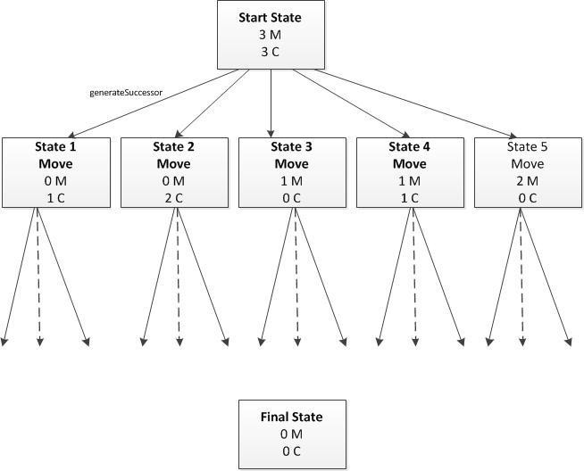

**Result**

# CONCLUSION

There are many other search methods and variants on search methods and variants on search methods .We do not have time to cover these but you can find out about some of them.

The concepts of states and operators and gave a graph traversal algorithm that can be used as an problem solving tool .We applied this to solve the missionary and cannibal problem.

**REFERENCES**

* **Research gate**
* **Wikipedia**
* **Google**

**…Thank You…**